**Authentication API call**

Updated 9-27-2013 Ola lawal

** add header below to request for JSON formatted responses **

**Content-Type: text/json**

Create user workflow

[3/24/2013 10:55:25 PM] himanshi vishnoi: 2)

User Data needed to create profile: (this can be got from the device directly or if not allowed

Entered in by the user) i.e. if user signing in with twitter or Facebook API’s a lot of that data can be got from there.

Username

Password

Confirms password

Email address

Email address confirms

Birth Date

Country

City

State Province (optional)

Zip or Postal

Screen Name

**Workflow steps:**

-Collect user data

-validate data

-create the profile

-collect user photo

-display activation page (require activation code) ALLOW user to BYPASS this I.e. activate later

-send user to their profile home page after photo collected.

Data must be correct before the profile is created the validation details are explained in the validation section after the geographical data is explained.

Initially display splash screen

-on application load

**Page - Splash Screen**

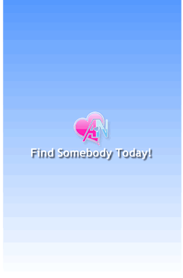

Display Logon Screen next

Screen name: **Log On**

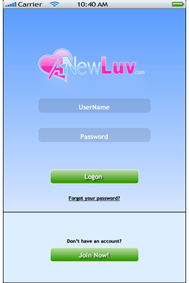

Existing user forgot password screen – if user clicks the forgot your password

Screen Name – **Password Recovery**

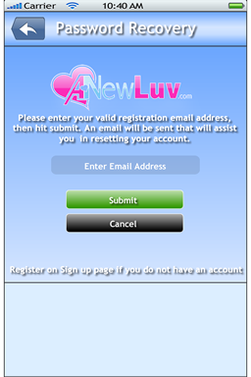

**Create new User Profile – if user clicks join now display terms of use splash screen**

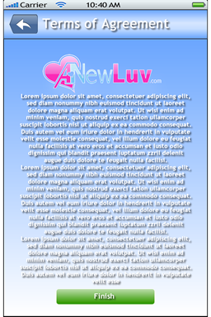

**Initial user Creation Steps**

Two options for logging in

* new users

i) Normal account creation

ii) Account creation via Facebook

2) Existing user

1) New user s

i) Normal account creation

Steps:

1) Gather registration data based on the order of the screens:

a) General profile data

Registration 1

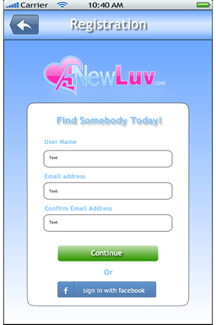

-**Username** - add a tooltip explaining that this is what the user uses to log on to the app from the website or the app if they log out of the app.

-**Email Address** – pre-populate this value with the users AppleID email address if accessible via API, in case of android attempt to use GoogleID which is also their Google app store id. If that is not available leave blank and force user to enter it. Add tootip stating that this is needed for updates such as email and account notifications.

-**Screen Name**- add a tooltip explaining that since the username is a private value, screen name is the name other users will know you as. I.e. a nickname.

Registration2

Next screen on mobile UI

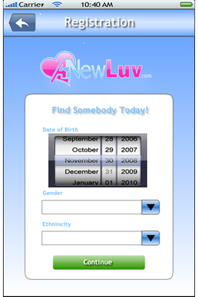

-**Birthdate** – add tootip starting must be 18 and older.

-**Gender** – gender list is populated from this service call:</Anewluv.Web.Services.Common>/Anewluv.Web.Services.Common

[http://173.160.122.195/Anewluv.Web.Services.Common/LookupService.svc/Rest/getgenderlist](http://173.160.122.195/Anewluv.Web.CommonService/LookupService.svc/Rest/getgenderlist)

See the **LookupService.docx** document for details on this call

-**Ethnicity** – is also populated by the lookup service:

[http://173.160.122.195/Anewluv.Web.Services.Common/LookupService.svc/Rest/help/operations/getethnicitylist](http://173.160.122.195/Anewluv.Web.CommonService/LookupService.svc/Rest/help/operations/getethnicitylist)

See the **LookupService.docx** document for details on this call

</Anewluv.Web.Services.Common>

</Anewluv.Web.Services.Common>

B) Location data

Registration3

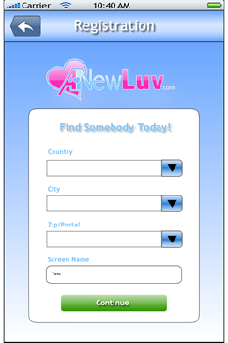

Preliminary step

b) Geographical data

**FIXED**

**- Country List – populated by the geoservice**

-access the current country list from the service since it is subject to change and possibly store it locally on the app using the following service call store it in local storage

[http://173.160.122.195/Anewluv.Web.Services.Spatial/GeoService.svc/Rest/getcountryandpostalcodestatuslist/](http://173.160.122.195/Anewluv.Web.GeoService/GeoService.svc/Rest/getcountryandpostalcodestatuslist/)

See the **GeoService.docx** document for details on this call

Anewluv.Web.Services.Spatial/GeoService.svc

See the validation sections in this documentation for further details on how to use these results

*** note this method is fixed and working now ***

-

Now that preliminary step is done moving forward:

**i) IF access to location was allowed**

Prepopulate country; city and store latitude and longitude in local storage since it is a displayed field but is also needed on the profile create.

**Country** – get from phone location – pre-populate

**City** – get from phone location – pre populate

**Postal Code – Not needed if we have lat and long data from phone, otherwise populate using the service call in the. Skip the manual data population for postal code if latitude and longitude is available**

If we have a country that has a postal code (see **an** above) prepopulate the postal code dropdown list using manual data population for postal code

Anewluv.Web.Services.Spatial/GeoService.svcAnewluv.Web.Services.Spatial/GeoService.svc

**Latitude and Longitude -**

Will be populated from GPS of the mobile device so store this data into temporary storage after country, city, postal code (if available) has been already gathered.

**ii) IF access to location was NOT allowed**

Prepopulate country; city and store latitude and longitude in local storage since it is a displayed field but is also needed on the profile create.

<http://173.160.122.195/Anewluv.Web.Services.Spatial/GeoService.svc/Rest/getcountryandpostalcodestatuslist/>

it also returns the postal code status so you know if postal code needs to be handled after city

<http://173.160.122.195/Anewluv.Web.Services.Spatial/GeoService.svc/Rest/getcountrylist/>

Is optional which is why it is at the end

[http://173.160.122.195/Anewluv.Web.Services.Spatial/GeoService.svc/Rest/getfilteredpostalcodesbycountrycityandfilter/{COUNTRY}/{CITY}/{FILTER}](http://localhost/Anewluv.Web.Services.Spatial/GeoService.svc/Rest/getfilteredpostalcodesbycountrycityandfilter/%7bCOUNTRY%7d/%7bCITY%7d/%7bFILTER%7d)

example

[http://173.160.122.195/Anewluv.Web.Services.Spatial/GeoService.svc/Rest/getfilteredcitybycountryandcityfilter/unitedstates/minnea](http://localhost/Anewluv.Web.Services.Spatial/GeoService.svc/Rest/getfilteredcitybycountryandcityfilter/unitedstates/minnea)

Anewluv.Web.Services.Spatial/GeoService.svcAnewluv.Web.Services.Spatial/GeoService.svc

**Manual Data population using Anewluv Services if Geo Data not available on phone**

**- Country – populated by the geoservice**

-access the current country list from the service since it is subject to change and possibly store it locally on the app using the following service call store it in local storage

[http://173.160.122.195/Anewluv.Web.Services.Spatial/GeoService.svc/Rest/getcountryandpostalcodestatuslist/](http://173.160.122.195/Anewluv.Web.GeoService/GeoService.svc/Rest/getcountryandpostalcodestatuslist/)

See the **GeoService.docx** document for details on this call

**- City – populated by the geoservice**

-access the list of available cities based on the selected country, remember the country can be pre populated or selected from the previous geoservice call.

[http://173.160.122.195/Anewluv.Web.Services.Spatial/GeoService.svc/Rest/getfilteredcitiesbycountryandfilter](http://173.160.122.195/Anewluv.Web.GeoService/GeoService.svc/Rest/getfilteredcitiesbycountryandfilter)

See the **GeoService.docx** document for details on this call

**- Postal code – populated by the geoservice**

-access the list of available postal codes using existing country and city and a filter.

[http://173.160.122.195/Anewluv.Web.Services.Spatial/GeoService.svc/Rest/getpostalcodesbycountrycityfilter](http://173.160.122.195/Anewluv.Web.GeoService/GeoService.svc/Rest/getpostalcodesbycountrycityfilter)

See the **GeoService.docx** document for details on this call

**Latitude and Longitude -**

Use this service call to get the longitude and latitude:

TWO options

1. If the user selected a country that DOES NOT have postal codes (HaspostalCodes == false ) use this call:

[http://173.160.122.195/Anewluv.Web.Services.Spatial/GeoService.svc/Rest/help/operations/getgpsdatalistbycountrycitystateprovince](http://173.160.122.195/Anewluv.Web.GeoService/GeoService.svc/Rest/help/operations/getgpsdatalistbycountrycitystateprovince)

Anewluv.Web.Services.Spatial/GeoService.svcSee the **GeoService.docx** document for details on this call

Anewluv.Web.Services.Spatial/GeoService.svc

2. If the user selected a country that HAS a postal code (HasPostalcodes == true)

[http://173.160.122.195/Anewluv.Web.Services.Spatial/GeoService.svc/Rest/getgpsdatalistbycountrycitypostalcode](http://173.160.122.195/Anewluv.Web.GeoService/GeoService.svc/Rest/getgpsdatalistbycountrycitypostalcode)

See the **GeoService.docx** document for details on this call

Anewluv.Web.Services.Spatial/GeoService.svcAnewluv.Web.Services.Spatial/GeoService.svc

Validation of above Entered values must happen before data is submitted

Validation details:

-data validation:

Email address - must be valid email address format!

Screenname

----------

Must be at least six chars, can contain special chars

Username

Must be at least six chars, can contain special chars within reason

Finally add the username and password

----------

**Validation of geo data**

-location data city,country,longitude,lattitude ,stateprovince - can be generated from phone

or use the geoservice to get that data.

-if user opts to turn off gelocation on phone we still have to find a way to verify that the user enters in

Location data that matches what is on their phone/tablet , so maybe not let them turn it off

-verify the geodata if manually entered in using the geoservice call

<http://173.160.122.195/Anewluv.Web.Services.Spatial/GeoService.svc/Rest/verifyorupdateregistrationgeodata>

Anewluv.Web.Services.Spatial/GeoService.svcmanual validation:

Anewluv.Web.Services.Spatial/GeoService.svcAnewluv.Web.Services.Spatial/GeoService.svcAnewluv.Web.Services.Spatial/GeoService.svcAnewluv.Web.Services.Spatial/GeoService.svc

using the city and country to create the filtered list of postal codes.

Two was of creating a new user account

**1) Non Facebook or openID user**

-prompt use that this app requires access to your location

-gather user data and fill out the RegisterModel/creatuser:

**\*\*\*\*Upadated 7/12/2013 \*\*\*\*\***

**ProfileModel** replaces common strings like email since you cannot pass special chars like @ and / as well as GUIDS in a rest URL

all the member actions user a common json body to pass items to the server here is the format. You only need to pass the values related to the call you are making.

{ "activationcode":"String content",

"email":"String content"

, "openididentifier":"String content",

"openidprovider":"String content",

"photoid":"1627aea5-8e0a-4371-9022-9b504344e724",

"profileid":2147483647,

"screenname":"String content",

"securityanswer":"String content",

"securityquestion":"String content",

"sessionid":"String content",

"username":"String content"

}

**\*\*\*\*Updates end 7/12/2013 \*\*\*\*\***

**CREATE user after the data is validated**

Method call:

[http://173.160.122.195/Anewluv.Web.Services.Authentication](http://173.160.122.195/Anewluv.Web.AuthenticationService/MembershipService.svc/Rest/createuser)*[/](http://173.160.122.195/Anewluv.Web.AuthenticationService/MembershipService.svc/Rest/createuser)*[AuthenticationService.svc/Rest/createuser](http://173.160.122.195/Anewluv.Web.AuthenticationService/MembershipService.svc/Rest/createuser)

see documentation on this service call at **AuthenticationAndMembershipService.docx**

this is a POST method…

- get profileinformation after creation

Two options to get the profile id

[http://173.160.122.195/Anewluv.Web.Services.Members/MembersService.svc/Rest/getprofileidbyusername](http://localhost/Shell.MVC2.Web.MembersService/MembersService.svc/Rest/getprofileidbyusername)

see documentation on this service call at **MembersService.docx**

or

[http://173.160.122.195/Shell.MVC2.Web.MembersService/MembersService.svc/Rest/getprofileidbyscreenname](http://localhost/Shell.MVC2.Web.MembersService/MembersService.svc/Rest/getprofileidbyscreenname)

see documentation on this service call at **MembersService.docx**

then use the profileID information to populate photos below...

**photos – adding**

-A Profile Photo is also required – the ability to allow the user to choose a photo from their device gallery or take a new one to add is needed. Additionally users need to be able to upload more than a single photo on their initial logon since this functionality exists currently on the website version.

Screen name Registtration4



Media/Photos can be uploaded via two methods and there are

[http://173.160.122.195/Anewluv.Web.Services.Media/PhotoService.svc/Rest/addphotos](http://localhost/Anewluv.Web.MediaService/PhotoService.svc/Rest/addphotos)

see documentation on this service call at **PhotoService.docx**

multiple photos or one photo can be added with this call

**Completion on Registration – password**

**Validation of password**

**Password must be six chars or more and contain no spaces**

**Paswords must match**

**Registration5**



**Confirm afte password validation is complete**

**Registration 6 - confirmation**



After user hits finish button begin activation process

**Page Activation**

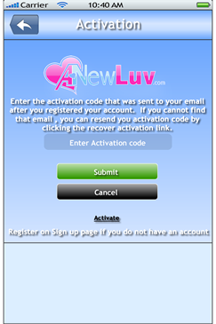

**Display Profile Activation message at this point :**

After re-directing them to their home page display the message : *“Please check your email address for your activation code and click the link to activate your profile. Activating your profile verifys your email address and ensures you can rescive email notifications when changes are made to your profile.”*

***p.s***

**If the user created a profile withoute using Facebook or an other open ID provider we do not need to validate their activation code via email.**

On mobile and web we still allow them temporary access to their homepage even withoute activation. The cannot communicate/update their profiles and use mail features until they activate however. This will be built into the service calls. They will only be able to search and view user profiles.

steps

to Activate the profile they can click on thier email and redicret to the activate profile page or type in the activate code from thier email address along with email addres

display this page if user doe not have activation code – need a button on **Activation** page

**Page - RecoverActivation**

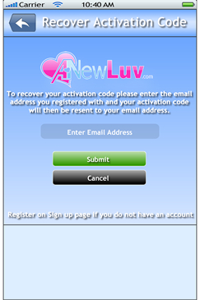

if the forgot thier activation code they can call this method to have it re-emailed to them:

use this call to retrieve the activation code of a user who lost or forgot it or did not activate on initial creation.

[http://173.160.122.195/Anewluv.Web.Services.Authentication/AuthenticationService.svc/Rest/recoveractivationcode](http://173.160.122.195/Anewluv.Web.AuthenticationService/MembershipService.svc/Rest/recoveractivationcode)

see documentation on this service call at **AuthenticationAndMembershipService.docx**

to activate profile us the call :

[http://173.160.122.195/Anewluv.Web.Services.Authentication/AuthenticationService.svc/Rest/activateprofile](http://173.160.122.195/Anewluv.Web.AuthenticationService/MembershipService.svc/Rest/activateprofile)

see documentation on this service call at **AuthenticationAndMembershipService.docx**

end of updates for this section **\*\*\*\*Upadated 7/12/2013 \*\*\*\*\***

2. Creation of FACEBOOK, YAHOO and GOOGLE and other Open ID type profile starts here

-use image from Facebook using device API's and follow the same process as above.

Final page of registration page

**Page: Registration 6 - Registered**

